- tree : Display the content of batch14
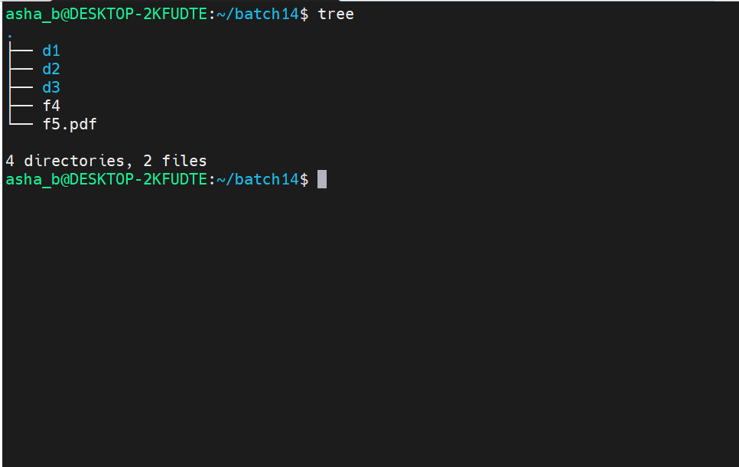
- ls : Display the list of files and directories in a pwd
ls -l : Display in a long format
ls -lt : Display in a long format from latest to oldest
ls -lrt : Display in a long format from oldest to latest
ls -a : Display all the hidden files
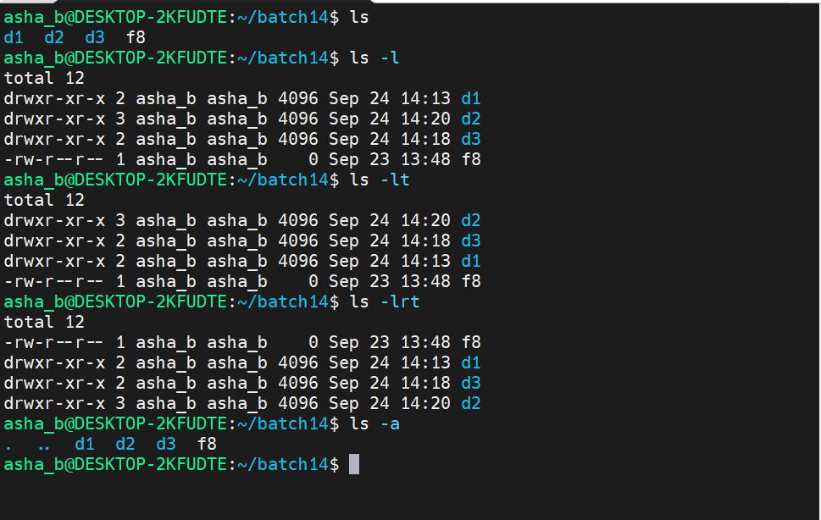
- history : Display all the commands executed previously
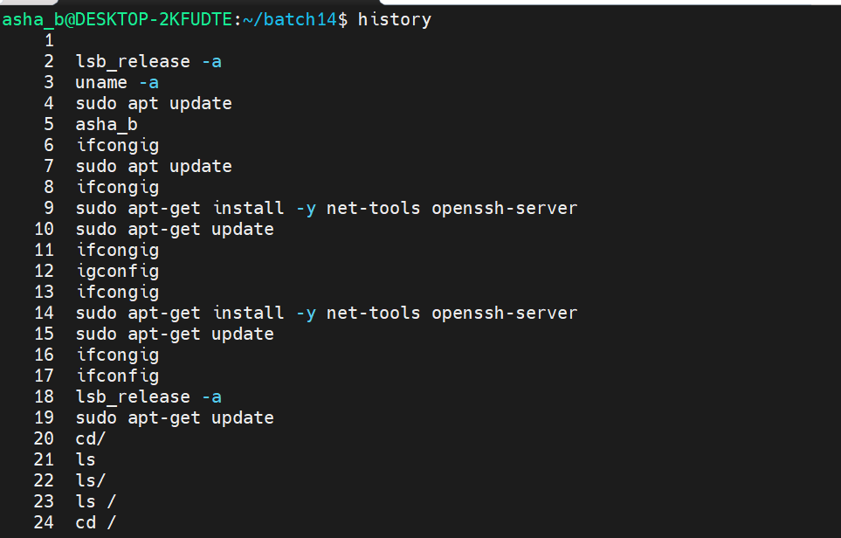
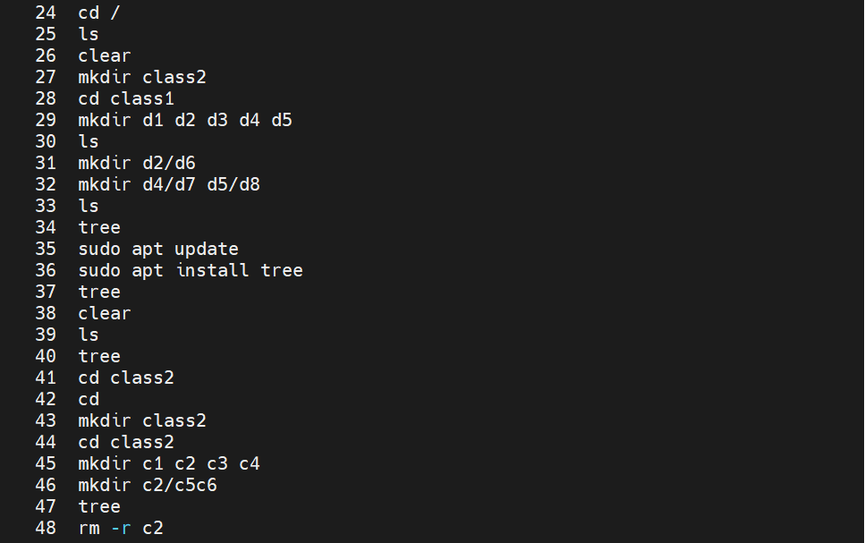

- date : Display the current system date and time
- uname : Display the name of the operating system
- whoami : Display the username
- who : Display the current logged in user with last system boot and time
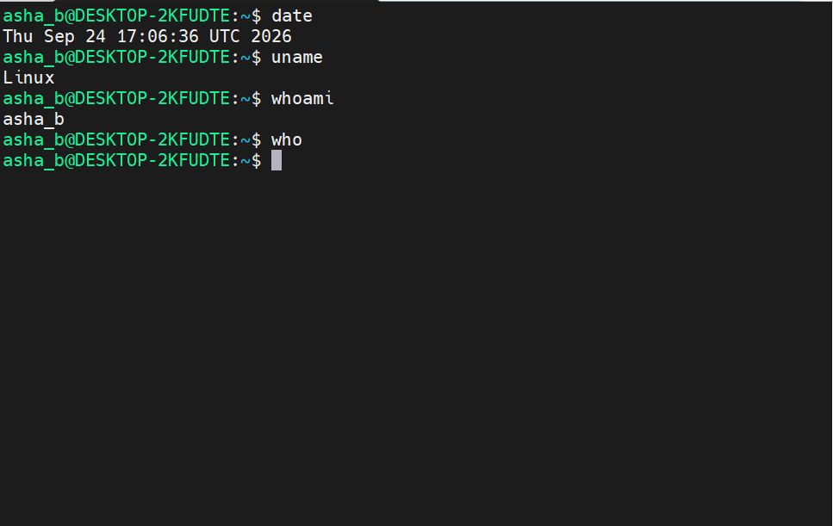

- Move the file f5.pdf from directory batch14 to directory d1
Command : mv /home/asha_b/batch14/f5.pdf /home/asha_b/batch14/d1
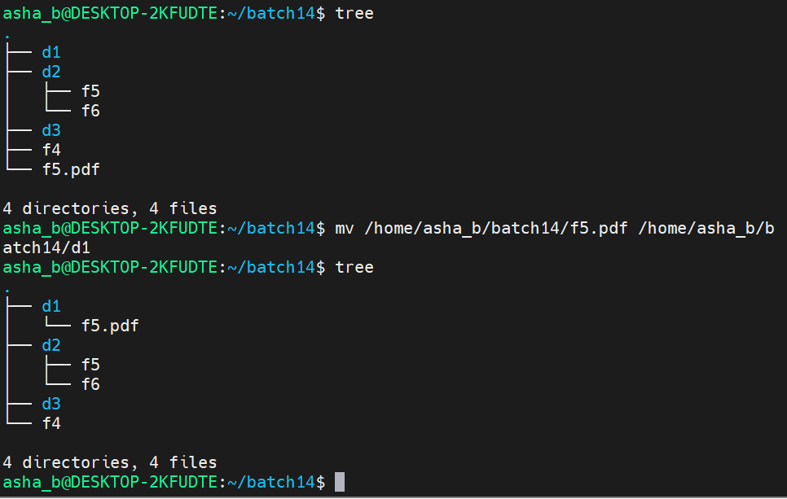
- Rename the file f4 to f8
Command : mv f4 f8
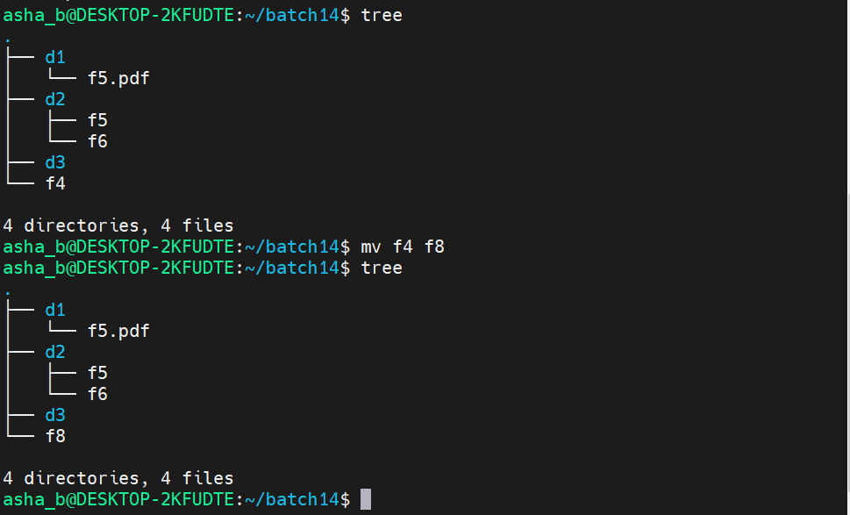

- copy the file f5.pdf from directory d1 to directory d3
Command : cp /home/asha_b/batch14/d1/f5.pdf /home/asha_b/batch14/d3

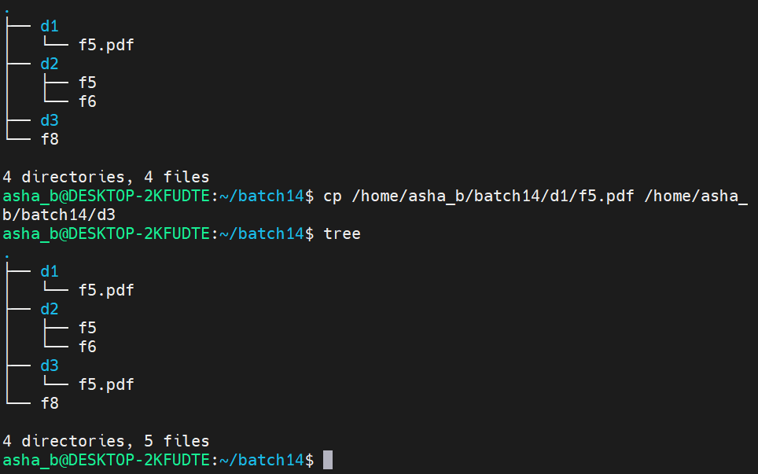

- copy a directory and its content from directory d1 to directory d3
Command : cp -r /home/asha_b/batch14/d3 /home/asha_b/batch14/d2
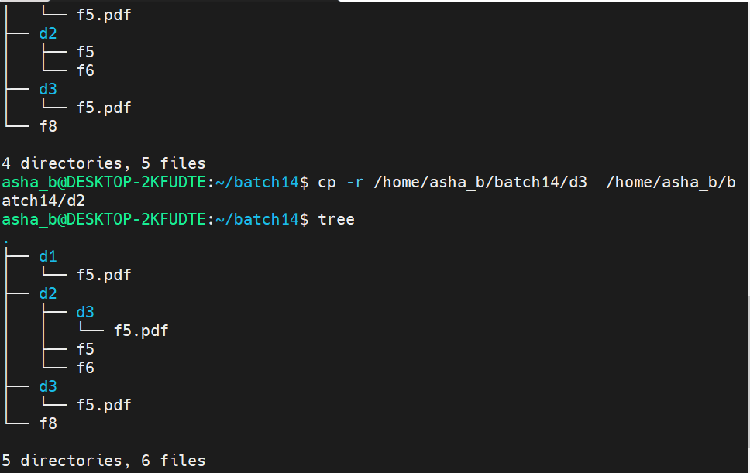

- cp –help : Check the details of copy command
